Tax Year 2023

Submission Status

Tutorial

Submission Status allows submitters to view the submission status, resubmission notice, errors, and detail submission information. If you would like to view report level information submitted on your behalf by a third party, use the Employer Report Status application. See the Employer Report Status Tutorial for more information.

1.0 Primary Pages
- Select the View Submission Status link on the EWR homepage. The system displays the “Submission Search” page.
See “Accessing EWR Suite of Services Tutorial” for how to access the EWR homepage.
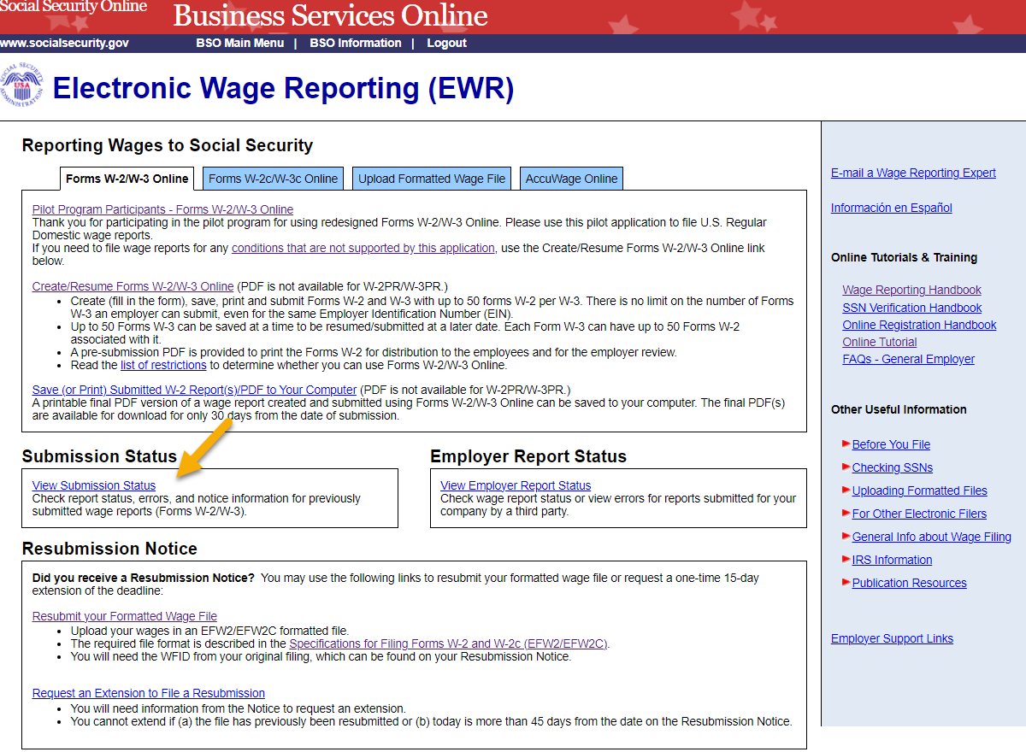
- On the Submission Search page, you can search a submission by Date or by WFID.
  - Search by date: Search by Date is a default tab. Select a Receipt Year and a submission date range, then select Continue button to go to the Search Results page. If there are no submissions matching the date range selected, the system displays the Search Results page with a message.
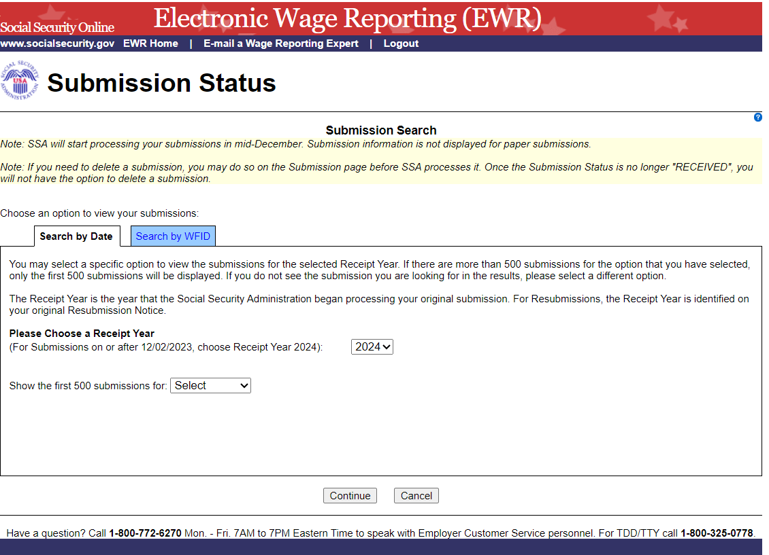
  - Search by WFID: Select the Search by WFID tab, then select a Receipt Year and enter WFIDs. If there are no submissions matching the WFIDs entered, the system displays the Search Results page with a message. If you do not enter the WFIDs, the system displays all of the WFIDs for the selected Receipt Year.
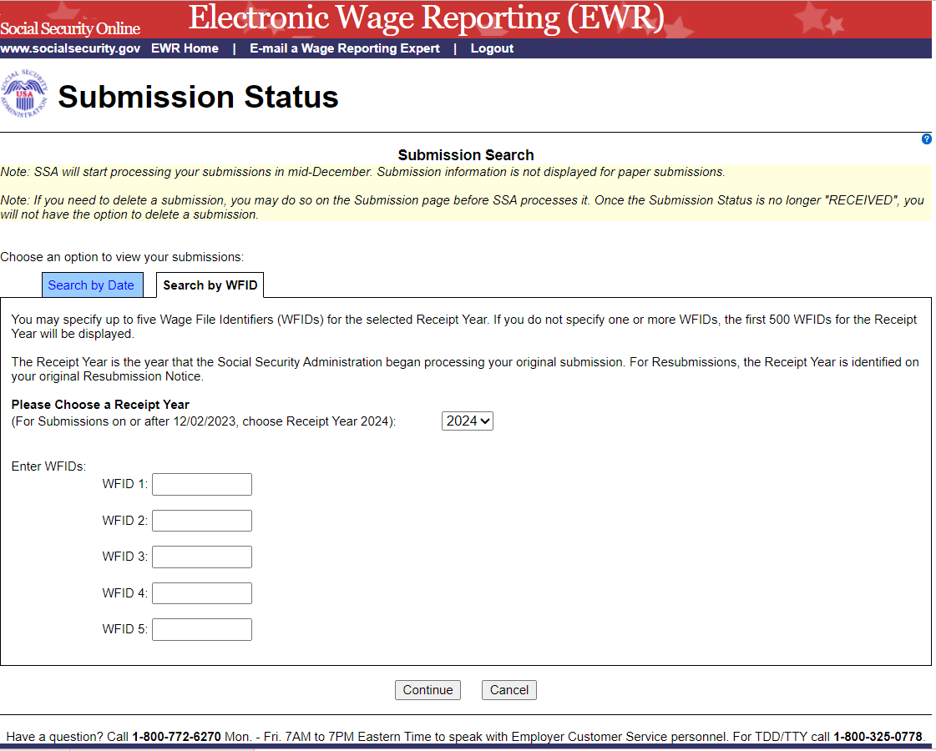
- On the Search Results page:
  - The Submission Status is displayed in the Status column. The possible submission statuses are: RECEIVED, IN PROCESS, COMPLETE, RETURN, DELETE, and DUPLICATE .
  - Select the column header WFID, Status or Receipt Date to sort submissions accordingly.
  - Select the actual status to see an Explanation of Processing Status Code.
  - Select the Submission Details link in the Details column to see the “Submission” page. If the status is “RECEIVED”, the system displays the Submission page with a Delete This Submission button; if the status is “DELETE”, the system displays the Submission page with Overview and Current Status sections; if submission level error exists, the system displays the Submission page with submission error.
  - If Resubmission Notice exists, select the View Notice link in the Resubmission Notice column to see the Resubmission Notice.
  - Select the Back to Search button to return to the Submission Search page.
  - Select the Print Page button to print the Search Results page.
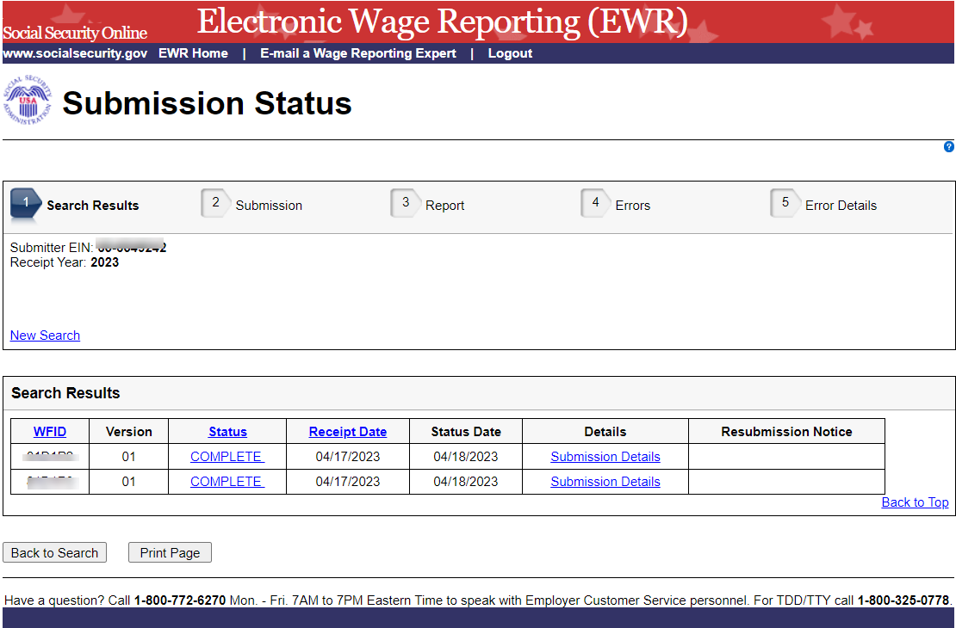
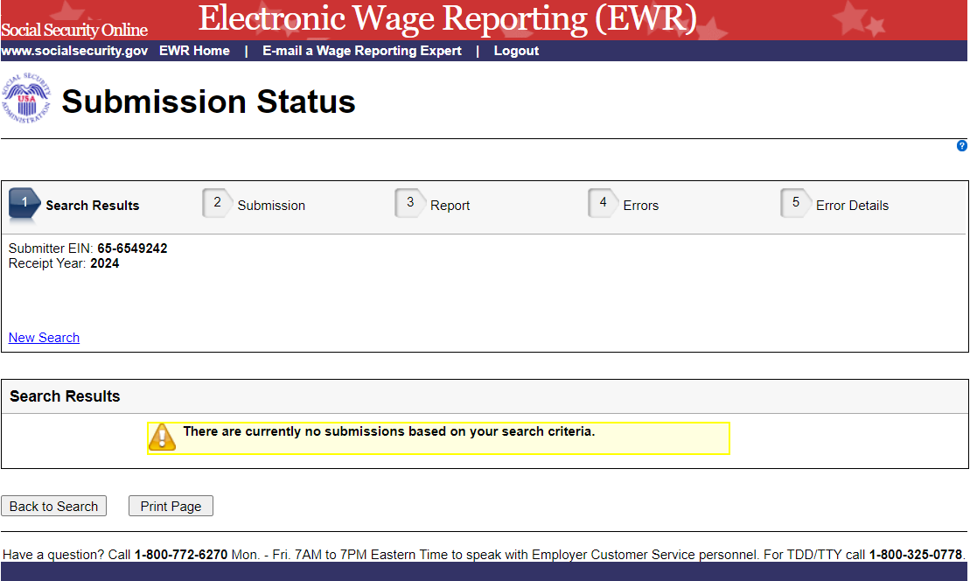
- On the Submission page:
  - Select any link in the Reports section to go to the Report page.
  - Select Search Results link or the Back to Search Results button to return to the Search Results page.
  - Select the Print Page button to print the Submission Details page.
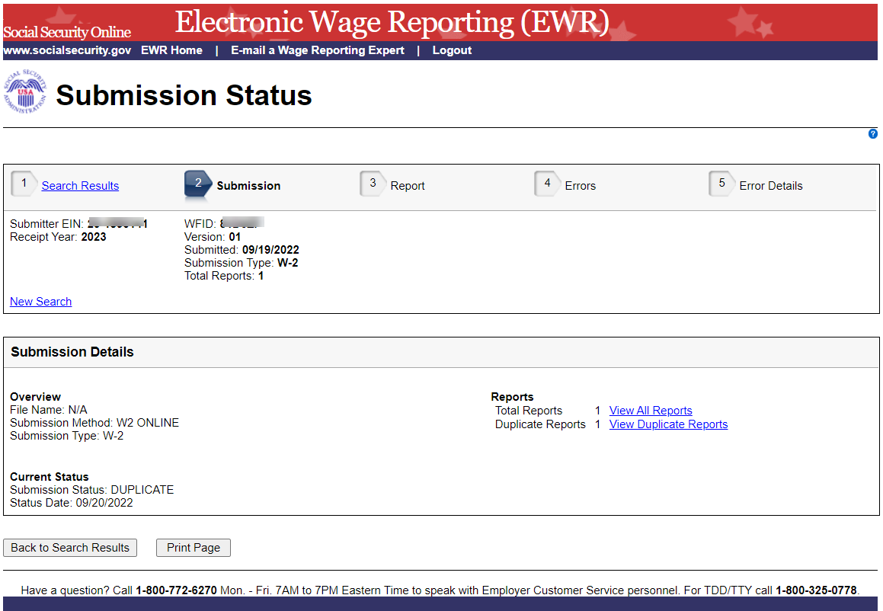
- On the Report page:
  - Select one of the filter radio buttons to filter the total reports accordingly. The report table will be refreshed.
  - Select the specific status link in the Status column to see an Explanation of Processing Status Code.
  - If the report has errors, select the # of Errors link to go to the Errors page.
  - Select the W-3 Details (or W-3c Details) link to view Detailed W-3 Information (or W-3c Information). See the screenshot below:
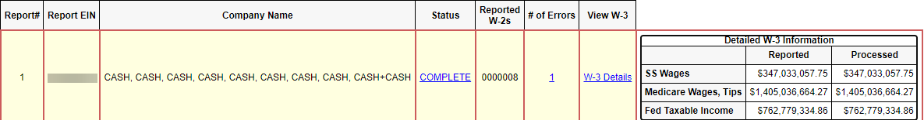
  - Select the Submission link or the Back to Submission button to return to the Submission Details page.
  - Select the Print Page button to print the “Report” page.
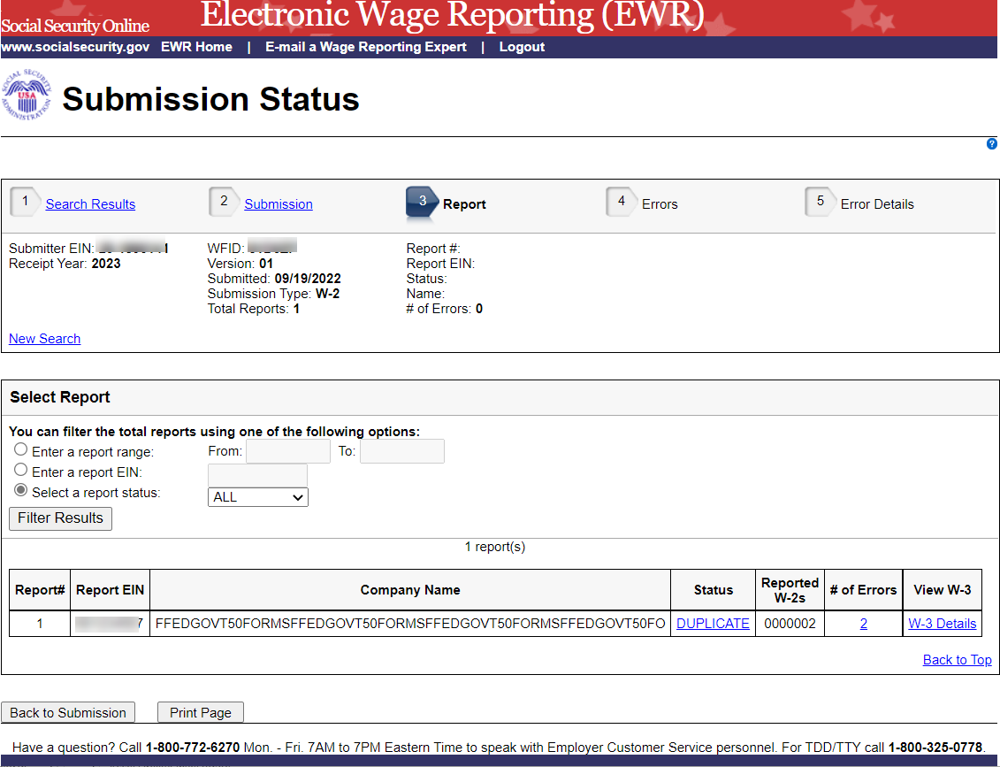
- On the Errors page:
  - Select the Importance link to see an Explanation of the Error Importance.
  - Select the Error Details link to go to the “Error Details” page.
  - Select the Report link or the Back to Report button to return to the “Report” page.
  - Select the Print Page button to print the “Errors” page.
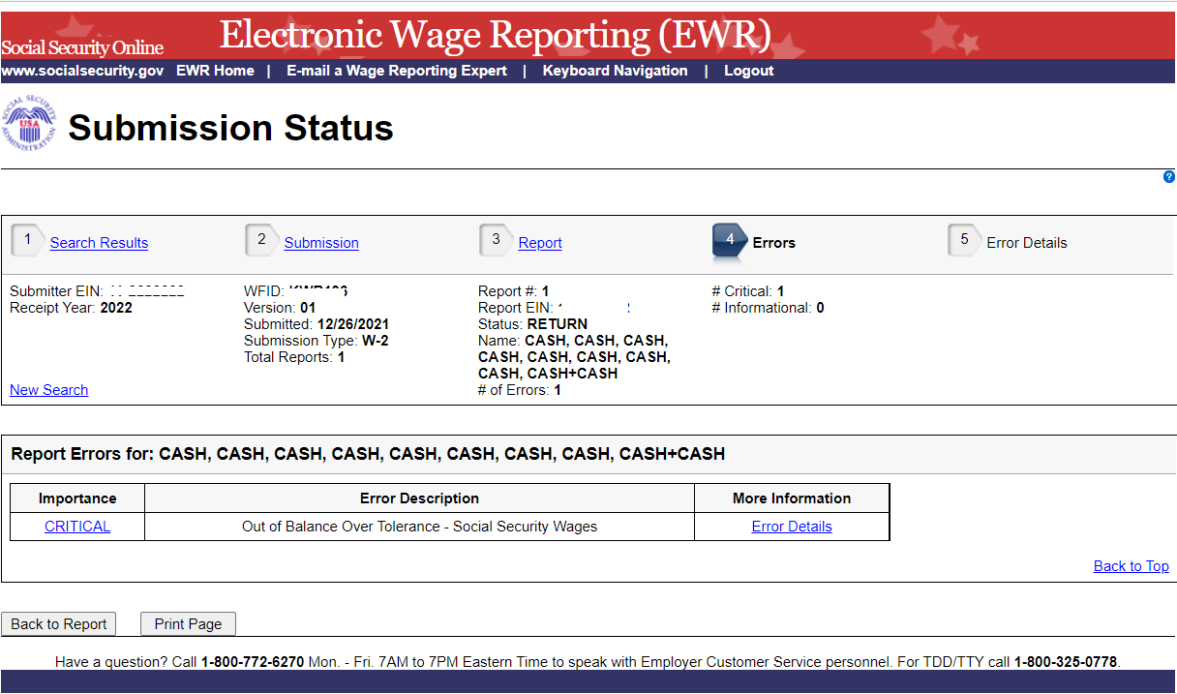
- On the Error Details page:
  - Select the Importance link to see an explanation of the Action that you may need to take.
  - Select the Online Error Reference Material link to see Employer W-2 Filing Instructions & Information.
  - Select the http://www.socialsecurity.gov/employer/accuwage link to see AccuWage Information and Software.
  - Select the Errors link or the Back to Errors button to return to the Errors page.
  - Select the Print Page button to print the “Error Details” page.
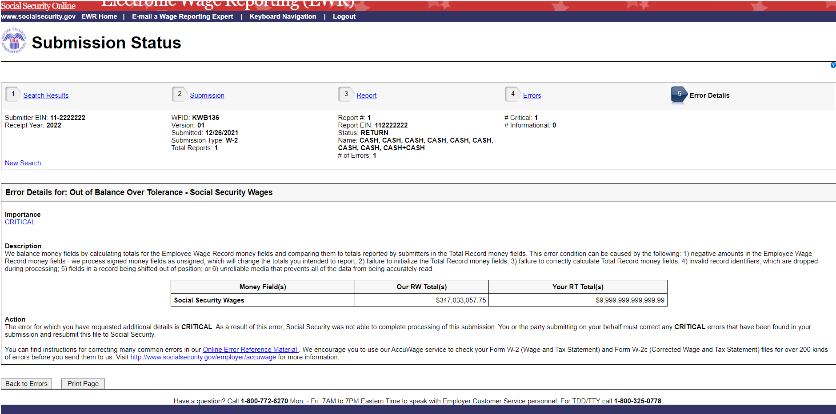

2.0 Other Pages

2.1 Explanation of Processing Status Code (Submission Status) Page

Users can access this page by selecting the specific status link in the Submission Status column or the Report Status column on any error page. Here is an example of “RECEIVED”.

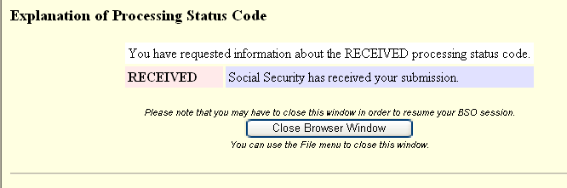

2.2 Explanation of Error Importance Page

Users can access this page by selecting either CRITICAL link or INFORMATIONAL link in the Importance column on any error page. Here is an example of “INFORMATIONAL” error.

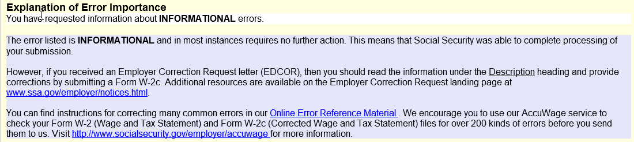

2.3 Submission (with Error) Page

The “Submission (with error)” page displays any errors at the submission level.

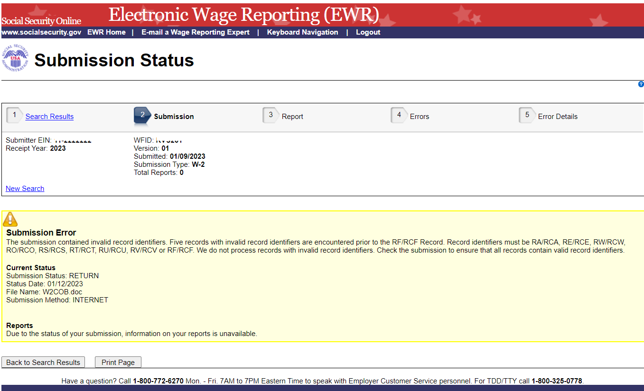

2.4 Submission (when status is “RECEIVED”) Page

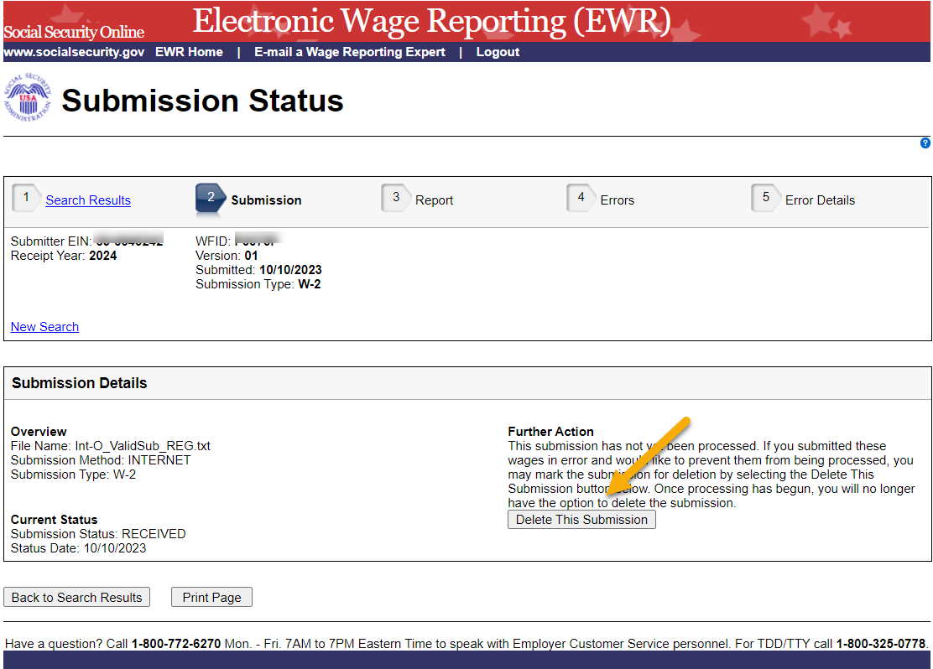

Submission (when status is “DELETE”) Page

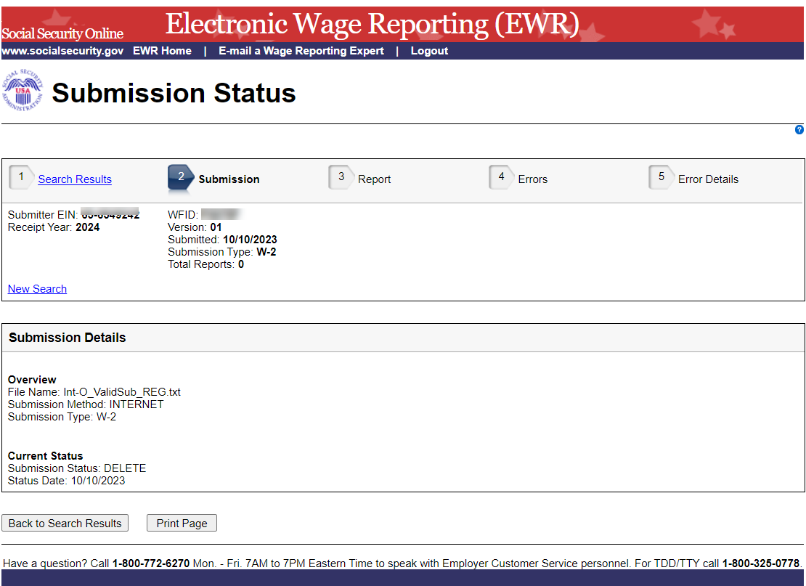

Resubmission Notice Page

Select the View Notice link on the Search Results page. The system displays the Resubmission Notice page.
