Tax Year 2023

Request Resubmission Extension (RRE)

Tutorial

- Select the Request an Extension to File a Resubmission link on the EWR homepage. The system displays the “Request Resubmission Extension” page.
See “Accessing EWR Suite of Services Tutorial” for how to access the EWR homepage.
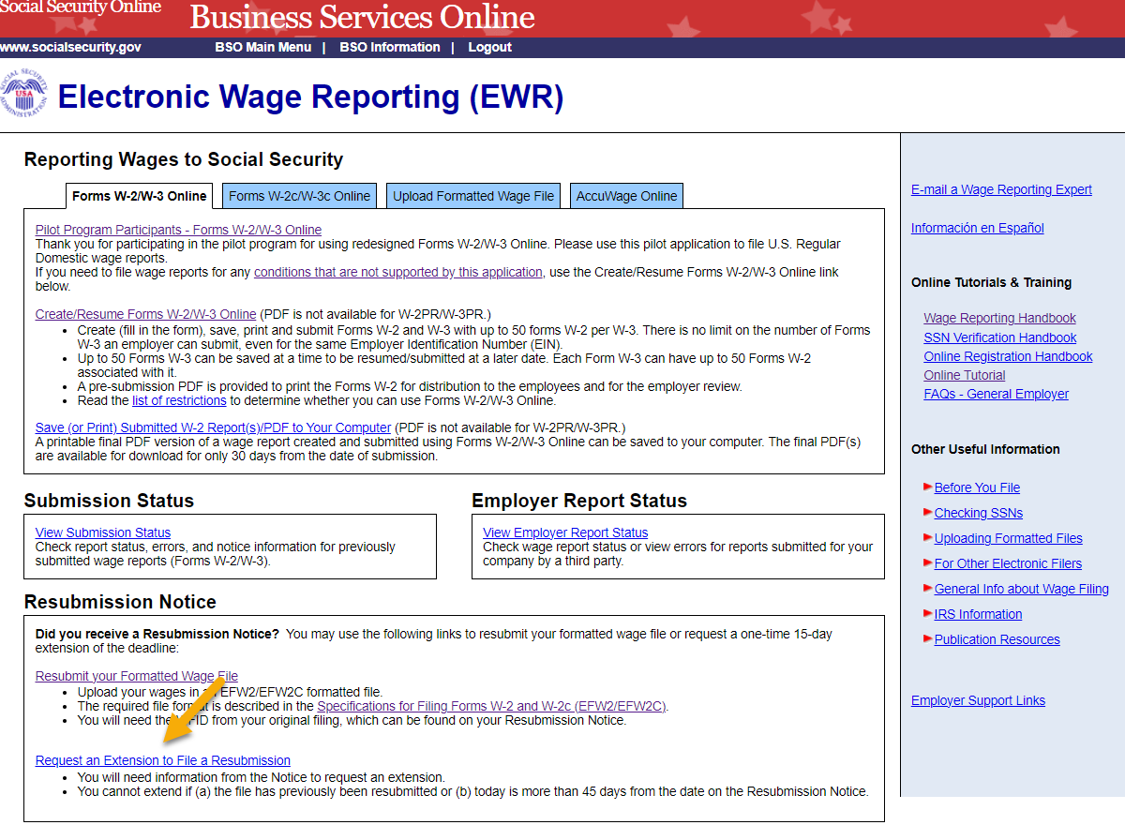
- On the “Request Resubmission Extension” page: enter your Employer Identification Number (EIN), Wage File Identifier (WFID), and select the Receipt Year (exactly as they appear on the Resubmission Notice you received from SSA.)
  - Select the Submit button to request an extension on the deadline for resubmitting your formatted wage file, the system displays the “Resubmission Extension Receipt” page.
  - To return to the EWR home page, select the Cancel button.
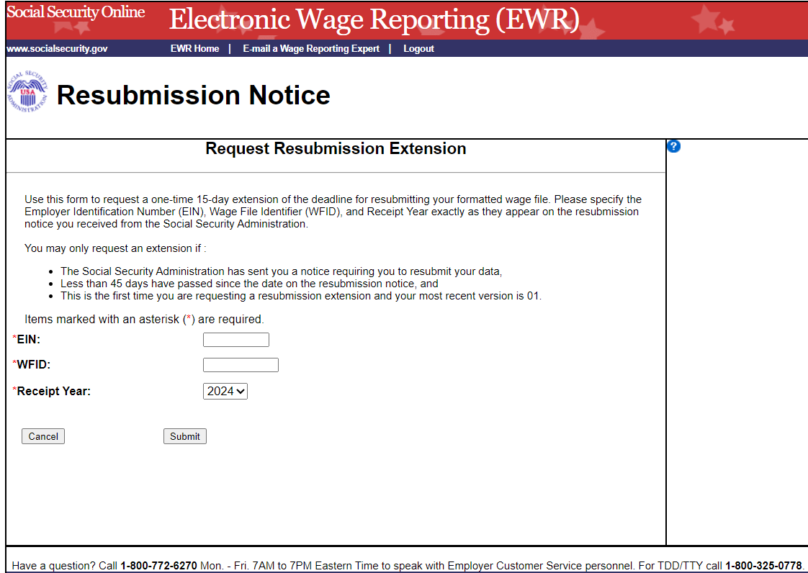
- On the “Resubmission Extension Receipt” page, select the EWR Home Page button to return to the EWR home page.
